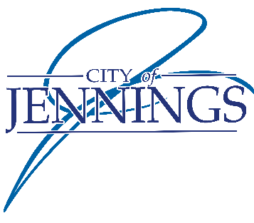

Request for Proposals

The City of Jennings is pleased to invite qualified and experienced project management firms to submit proposals for the position of Project Manager for our upcoming construction project, New Community Center. We are seeking a highly skilled and professional project manager to oversee and coordinate all aspects of the project, ensuring its successful and timely completion.
Project Overview: The recreation facility will consist of a pre-engineered metal structure with a footprint of approximately 16, 032 square feet.
Scope of Work: The selected Project Manager will be responsible for, but not limited to, the following tasks:
- Project Planning: Develop a comprehensive project plan outlining timelines, milestones, and resource requirements.
- Team Coordination: Lead and coordinate a multidisciplinary project team, ensuring effective communication and collaboration.
- Budget Management: Oversee project budgets, monitor expenses, and ensure adherence to financial constraints.
- Risk Management: Identify potential risks and develop strategies to mitigate them, ensuring the project stays on track.
- Quality Control: Implement and enforce quality control measures to guarantee the highest standards of construction.
Qualifications: Prospective bidders must possess the following qualifications:
- Proven track record of successfully managing construction projects of similar size and complexity.
- Extensive experience in project planning, budgeting, and resource management.
- Strong leadership and communication skills to effectively collaborate with project teams, stakeholders, and contractors.
- Knowledge of industry best practices, regulations, and compliance standards.
Proposal Submission Guidelines: Interested parties are invited to submit their proposals by March 20th 2024 by no later than 12:00PM.
Proposals should include the following:
- Cover Letter: Introduce your firm, provide an overview of your qualifications, and express your interest in the project.
- Company Profile: Outline your company's background, experience, and relevant capabilities.
- Project Management Approach: Detail your approach to project planning, team coordination, budget management, and risk mitigation.
- References: Provide references from previous clients for whom similar projects have been successfully completed.
Proposal Evaluation: Proposals will be evaluated based on the following criteria:
- Experience and Qualifications
- Project Management Approach
- Cost Competitiveness
- References
Please submit your proposal in a sealed envelope marked “New Community Center – C/O City Clerk” to Jennings City Hall at 2120 Hord Avenue, Saint Louis, MO 63136 and must be received no later than 12:00 p.m., WEDNESDAY, MARCH 20TH, 2024. At 1:00 pm all sealed bids shall be opened and read aloud by the City Clerk in the City Hall Council chambers. Bidders will need to enclose one (1) original and three (3) copies of the bid proposal.
Click here for more information on the project:
Binder2.pdf (cityofjennings.org)
We appreciate your interest in working with the City of Jennings and look forward to reviewing your proposal.

